**Project Design Phase-I**

**Solution Architecture**

|  |  |
| --- | --- |
| Date | 15.10.2022 |
| Team ID | B9-3A5E |
| Project Name | Digital Naturalist-AI Enabled Tool For Biodiversity Researchers. |
| Maximum Marks | 4 |

**Solution Architecture:**

Solution architecture is one of the foundational element of any project or organization. It is instrumental backbone that holds things together.

* The detailed and structured description of the feature, process and behaviour of the solution.
* It acts as the base of the solution to define, deliver, manage and operate the development process of the solution.
* It identifies the alternatives of the solution and its components.

**Solution Architecture Goals:**

* Providing a more efficient producing environment.
* Lowering costs and gaining cost-effectiveness.
* Providing a secure, stable, and supportable environment.
* Streamlining of day-to-day activities.

**Solution Architect Responsibility:**

* Analyzing the technology environment.
* Analyzing enterprise specific
* Analyzing and documenting requirement.

**Solution Architecture Diagram:**

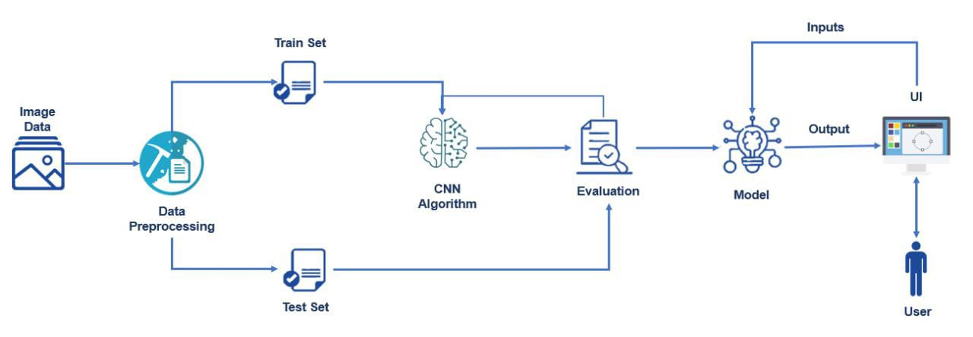

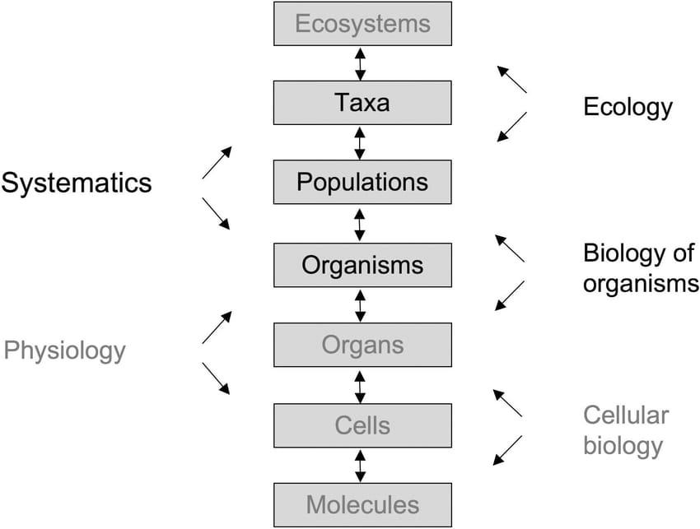

*Figure 1: Digital Naturalist- AI Enabled Tool For Biodiversity Researchers.*